Móz Launches New Laser Cut Metal Solutions
The Perfect Balance of Texture and Transparency

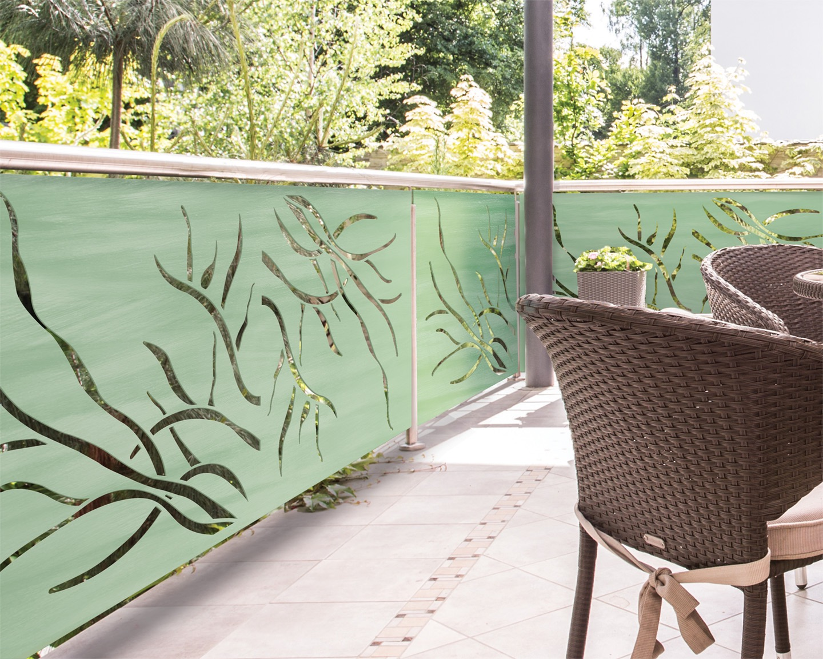
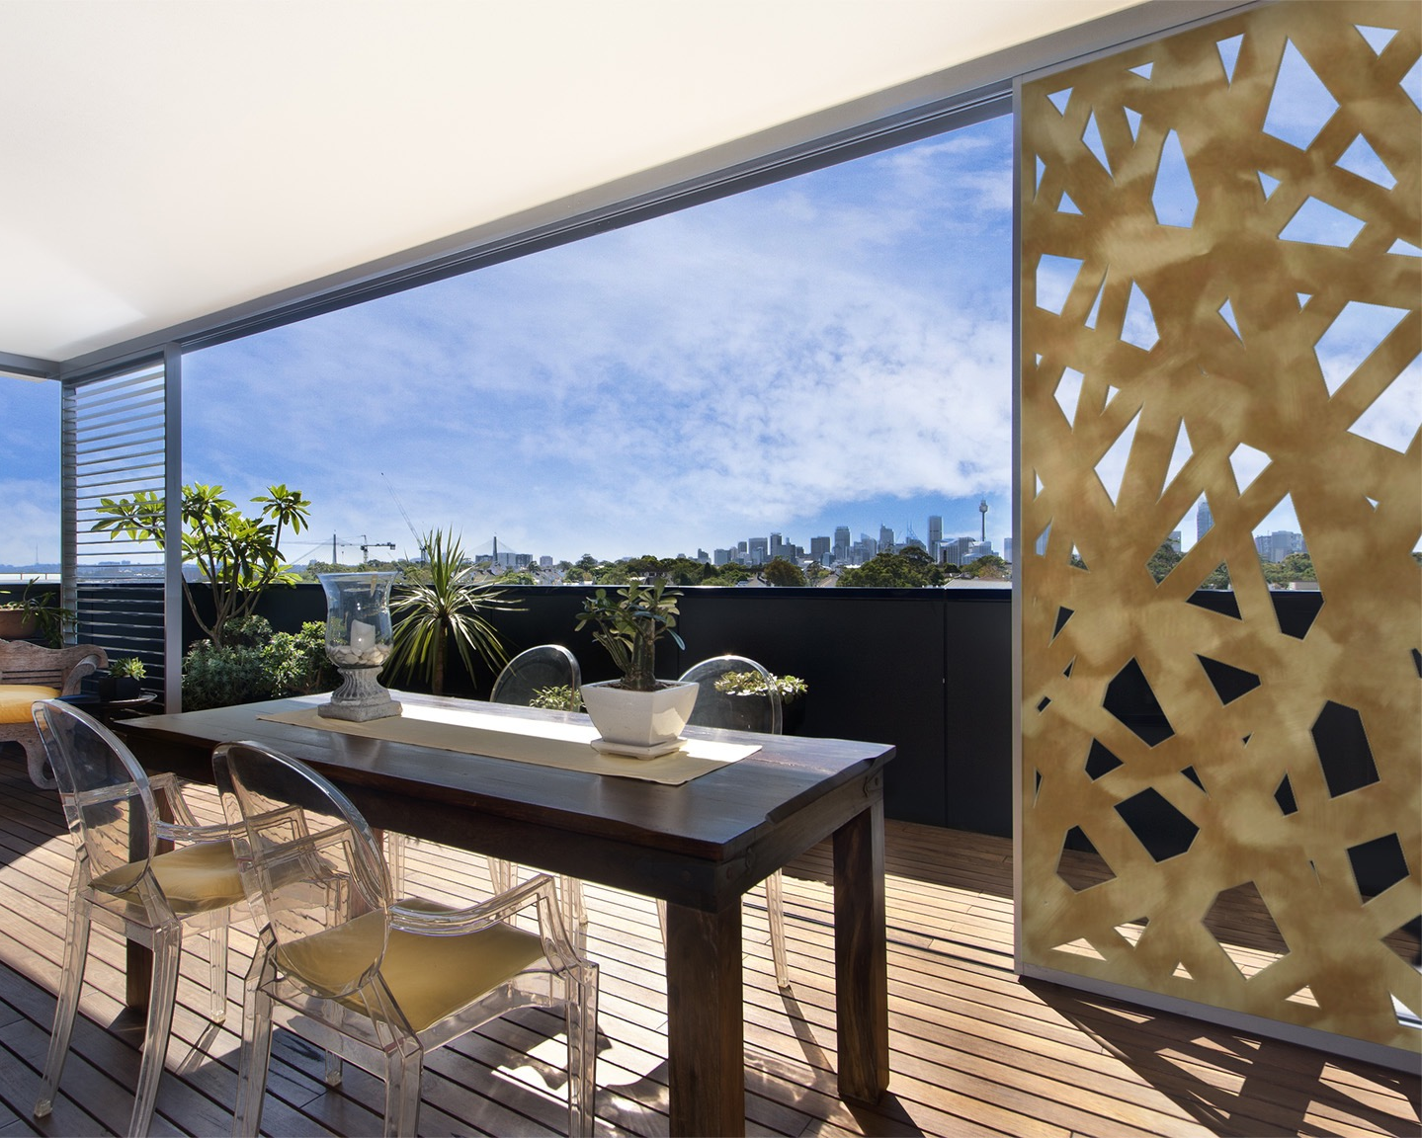
Oakland, CA (October 2016) – The new Laser Cut collection from Móz Designs redefines architectural metal materials by expanding the possibilities of the dynamic material using cutting-edge tooling and technology. The new collection of patterns strike the perfect balance of texture and transparency, providing a unique design solution for both interior and exterior applications.

With the Laser Cut collection, designers can seamlessly divide spaces with a reflective natural metal or a bold colorful pattern using a durable and cost effective material solution. The versatile collection has many uses - from an interior partition or feature wall to a stunning exterior facade.

Available in ten standard patterns with the ability to customize the size and shape of the metal cuts to control the amount of light and flow through the space. Designers can select from Móz’ extensive collection of colors and grains including gradients, metallics, neutrals and standard powder coatings to achieve their unique design goal.

All Móz metal products are rust-resistant and offer consistent color integrity, which is the result of a carefully curated handmade design process by a team of artisans in their Oakland-based manufacturing facility. Móz craftsmen redefine surfaces using a delicate balance of texture, grain and color to create unique architectural metals for projects of all sizes - from large scale technical projects to small installations. Móz metals are manufactured from recycled aluminum and contribute to LEED 2.0 MR Credit 4 – Recycled Content.

About Móz Designs
Móz Metals and Architectural Products designs and fabricates contemporary metal products in Oakland, CA. Móz’ collection of sophisticated materials and patterns, including gradients, metallics and neutrals are the result of continuous experimentation with cutting-edge tooling, engravings and equipment. Móz craftsmen redefine surfaces using a delicate balance of texture, grain and color to create unique architectural metals for projects of all sizes - from large scale technical projects to small installations. Móz’ innovative materials and products, custom solutions and dedication to customer service help clients achieve their design intent on time and on budget. For more information, visit www.mozdesigns.com or call 510.632.0853 to order product samples.

Press Contact
Amy Leedom
Paxson Fay PR
amy.leedom@paxonfay.com
(718) 924-4096

