For Immediate Release

August 23, 2016

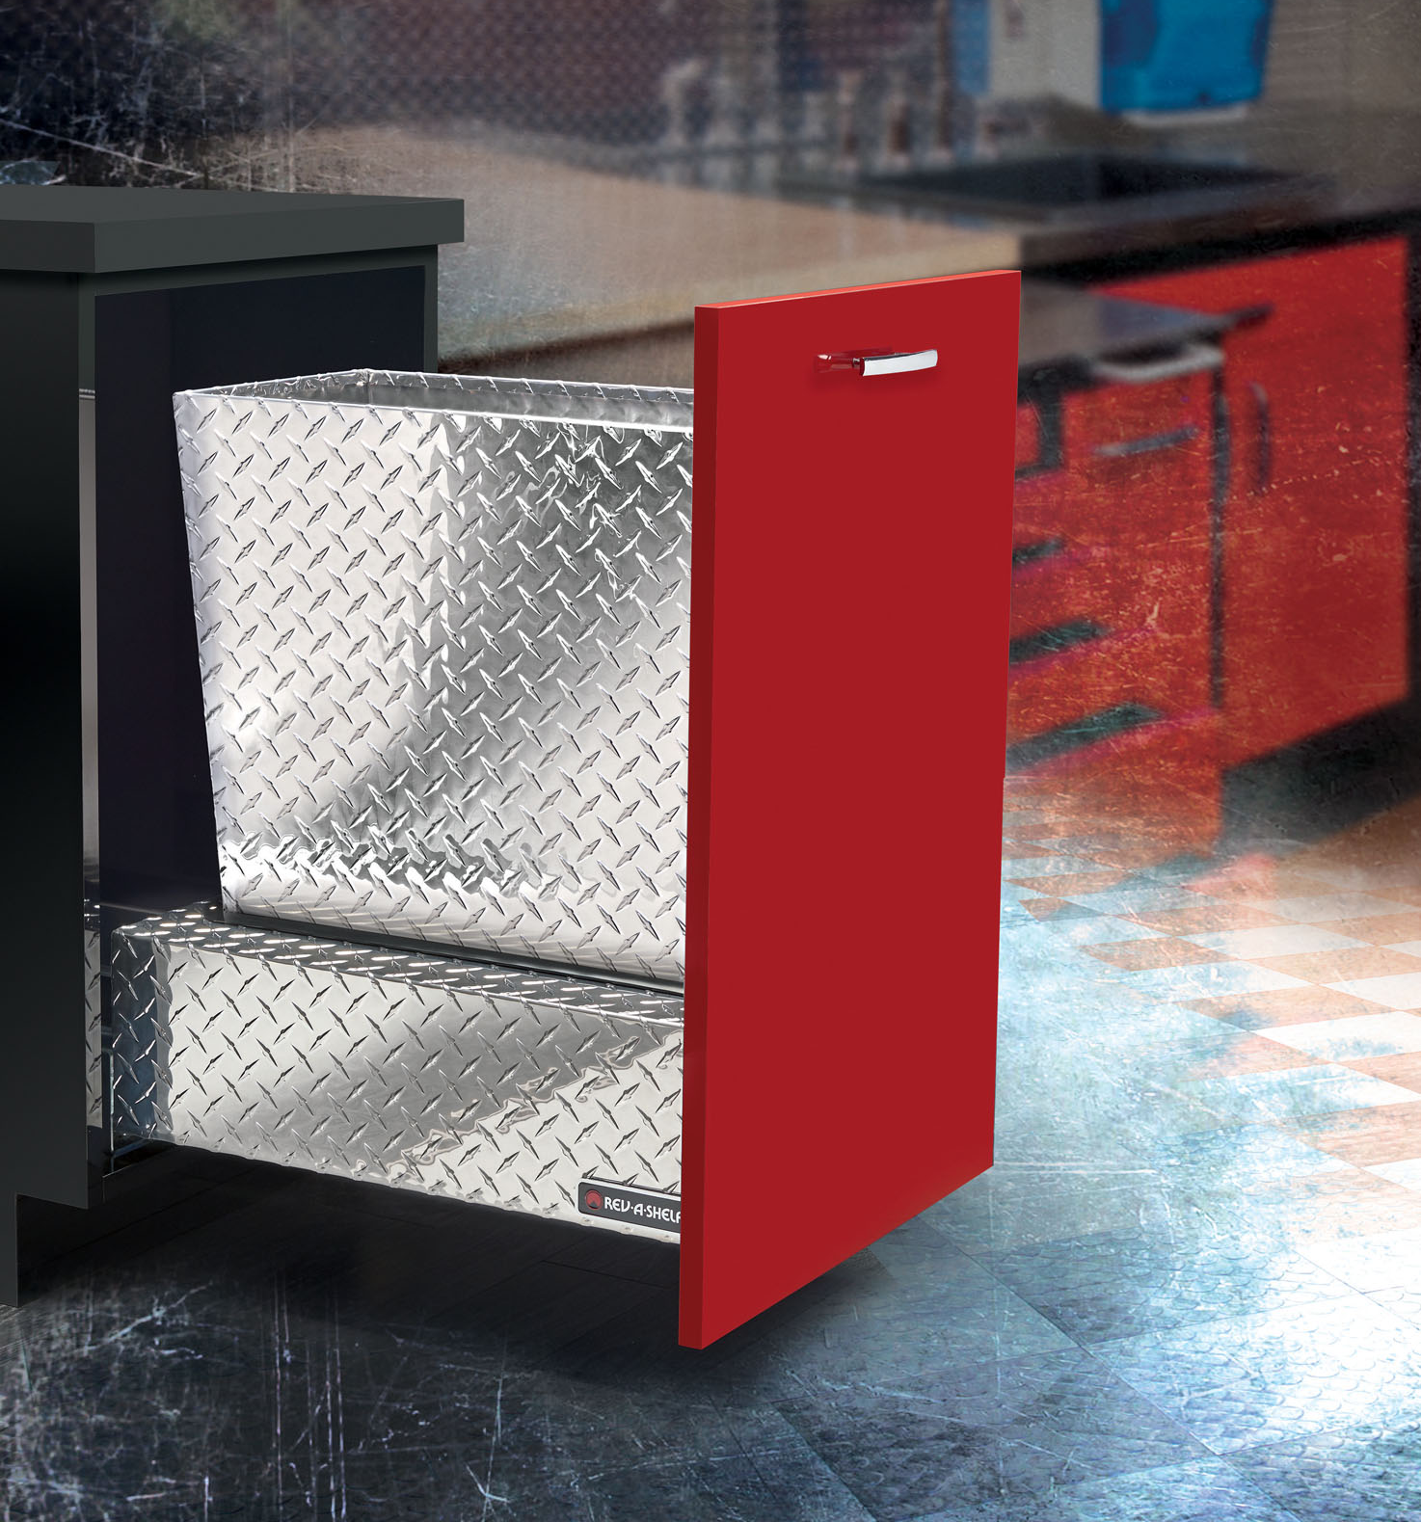
Rev-A-Shelf has always created the most ingenious accessories, and this waste solution is an industry-shocking first.
Named the Monster, this high-end waste container is going to be the must-have for garages, workbenches, and man caves across the country. It’s massive 10 gauge diamond plate bin and rugged body are sure to turn heads.
Don’t be fooled; The Monster didn’t get its name from being pretty. With 16 gauge aluminum diamond plate construction, six-point door mounting with three-axis trim adjustment and 400lbs rated slides that meet the most grueling demands, this waste container is built tough and ready to do your bidding. *When ordering the Monster Waste Container, you must order both the chassis and the container separately.

Single Waste Container Chassis
5159-21DM-1DP - 16-3/4” (426 mm) W x 22-3/4” (577 mm) D x 25-1/2” (646 mm) H (w/ 74Qt. can) $1,450.00
Waste Container 74 qt.
51-70-1DP - 11-5/8” (295 mm) W x 20-7/8” (530 mm) D x 24” (610 mm) H $841.00
Double Waste Container Chassis
5159-21DM-2DP - 16-3/4” (426 mm) W x 22-3/4” (577 mm) D x 20-3/8” (517 mm) H* 24-1/4” (616 mm) H** $1,537.00
*35 Qt. Containers **50 Qt. Containers

Waste Containers for Double Chassis
51-35-217 Double 35 w/lids 14-1/4” (361 mm) W x 10-1/2” (266 mm) D x 17-7/8” (453 mm) H $50.75
51-35-218 Double 35 w/lids 14-1/4” (361 mm) W x 10-1/2” (266 mm) D x 17-7/8” (453 mm) H $50.75
51-35-211 Double 35 w/lids 14-1/4” (361 mm) W x 10-1/2” (266 mm) D x 17-7/8” (453 mm) H $49.30
51-50-217 Double 50 w/lids 14-3/4” (375 mm) W x 10-11/16” (271 mm) D x 21-3/4” (553 mm) H $58.00
51-50-218 Double 50 w/lids 14-3/4” (375 mm) W x 10-11/16” (271 mm) D x 21-3/4” (553 mm) H $58.00
51-50-211 Double 50 w/lids 14-3/4” (375 mm) W x 10-11/16” (271 mm) D x 21-3/4” (553 mm) H $55.10

About Rev-A-Shelf LLC.
Established in 1978 as a division of Jones Plastic & Engineering, our product line began as metal and polymer Lazy Susan components manufactured for the largest U.S. cabinet manufacturers, and they have grown into the market leading innovator of quality functional residential cabinet storage, LED Cabinet Lighting and organizational products.

Rev-A-Shelf manufactures thousands of innovative accessories for your, kitchen, bath or closet. With the acquisition of Tresco Lighting, Rev-A-Shelf now offers a full line of L.E.D. lighting options for residential & commercial cabinetry and store display fixtures. Rev-A-Shelf’s primary markets are Cabinet Hardware Distributors, large OEM cabinet manufacturers, Lowes and Menards home centers, and a number of online web resellers.

