Contact: Tom Forsythe, Executive VP
Tel: +1-615-831-0888
Email: tom_forsythe@kyzen.com

Research reveals higher production yields with one minor adjustment

NASHVILLE — February 2016 — KYZEN announced that it will reveal the latest research findings from controlled laboratory tests conducted in the interest of improving stencil printing reliability at the 2016 IPC APEX EXPO. The research indicates consistently lower production yields are delivered when some of the industry’s most common cleaning agents are utilized in under-stencil wipe applications. Demonstrated improvements for a multitude of standard processes, solder pastes and laboratory conditions are being made available to help industry experts. Key findings and related video proofs also will be shared in Booth #1869, March 15-17, 2016 at the Las Vegas Convention Center.

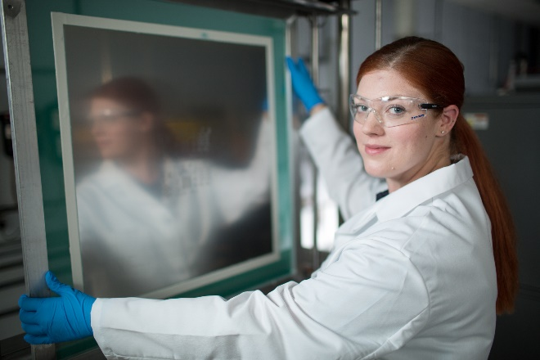
The evidence from this lengthy and objective study includes process videos and strongly supports the need for a wet wipe with an engineered solvent that matches to the flux composition. It concludes that reliable and acceptable assemblies start with a clean print. In addition, clean prints are more achievable on a reliable basis with engineered solutions, such as CYBERSOLV® C8882 than they are with standard IPA. In addition to sharing the results of the stencil reliability research findings, visitors to the KYZEN booth can acquire custom technical support to help reduce misprints and increase production yields at no cost.

CYBERSOLV® C8882 will be featured in the KYZEN booth at the IPC APEX EXPO. C8882 is a fast-acting stencil cleaning solvent designed for the under-stencil on printer wipe cleaning process. The solvent dries quickly, eliminating the streaking and smearing experienced with traditional cleaning solvents. “I’ve seen companies replace IPA and other engineered solutions with C8882 over the past year with significant improvements,” said Kevin Buckner, Western Regional Manager of KYZEN. “I love sharing this news because it is so reliable. It is non-flammable, removes all flux types and does not interact with or remove nano-coatings.”

With more than 25 years’ experience and more than 50 industry awards, KYZEN connects leading science with care to create the most effective cleaning solutions for each customer’s unique manufacturing process or problem.

For more information, call the KYZEN inside technical team at 615-236-6784.

KYZEN® and CYBERSOLV® are registered trademarks in the United States and other countries.

###

About KYZEN
KYZEN is a global leader in providing environmentally responsible, RoHS compliant precision cleaning chemistries for industries ranging from electronics and advanced packaging to metal finishing and aerospace applications. Since its founding in 1990, KYZEN’s innovative cleaning technologies, scientific expertise and customer support have been repeatedly recognized with the industry’s most prestigious awards. For more information, visit www.kyzen.com.

