The SCHMID Group introduces its innovative module line generation InfinityLine and the New Etching Options ("NEO") at the IPC 2016
February 05, 2016 - Freudenstadt / Germany. On the occasion of this year's leading trade show for PCB IPC in Las Vegas the SCHMID Group will present its new module line generation InfinityLine to the international expert audience for the very first time. Furthermore, innovative etching solutions made by SCHMID, which fundamentally improve the etching result, will be introduced under the title "NEO" (New Etching Options).
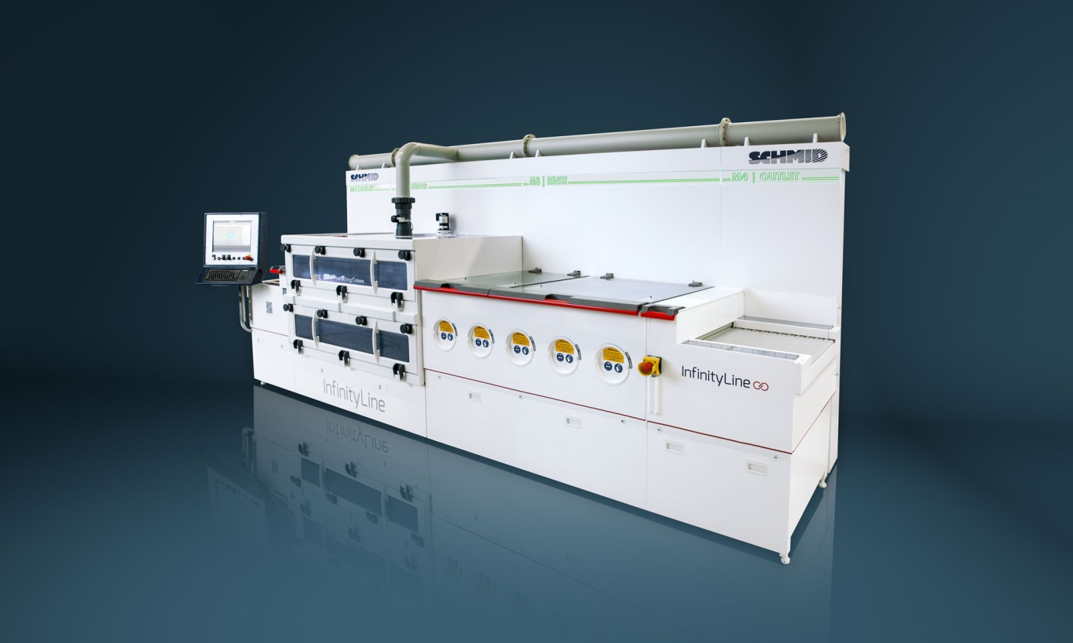

SCHMID InfinityLine
The InfinityLine is the combination and innovative optimization of the SCHMID CombiLine and PremiumLine. In addition to the proven SCHMID quality and performance, it offers several new highlights which are to the benefit of our customers. For instance, the InfinityLine offers an especially high user friendliness since measured values can be digitally recalled via a user tablet or externally via internet browser. In addition, optimized module lengths and the use of intermediate plates result in a significant reduction of chemical drag-out, leading to cost savings on the part of the customer and to an increased environmental friendliness.

With the InfinityLine PCB manufacturers are prepared for the future, since the new module line generation not only meets current but also future energy efficiency standards (such as IE3 and IE4); and thanks to numerous constructive measures the line has a particularly low wear and a considerably longer service life compared to the competition. Furthermore, the modular design of the line provides the opportunity for simple and cost effective technology upgrades, which sustainably secures the competitiveness of our customers.

"NEO": New etching solutions made by SCHMID
Under the term "NEO" (New Etching Options) SCHMID offers several optional expansions that significantly improve the etching result. This also includes a differentially graded nozzle arrangement for a higher etching performance and the option of vacuum etching which is suitable for etching of particularly fine structures and significantly contributes to increase the standard distribution and to improve the etching factor.
Another "New Etching Option" is provided by the expanded Fluid Dynamic Equipment, which significantly reduces defects during etching and enables an improved AOI (Automatic Optical Inspection) as well as a significant increase in yields of HDI circuit boards. Moreover, SCHMID now offers an expansion of the pressure range to a maximum of 4 bar spraying pressure and an optimized transport system which ensures more uniformity during etching.

SCHMID Group
For more than 150 years, SCHMID has been inventing solutions for dynamic industries and has experienced an impressive growth by successfully entering new businesses and international markets.
For over 50 years, we have been a recognized technology leader in the PCB sector in the areas of metallization, surface and resist technology as well as automation for PCB production and photo chemical milling. Contact-free and fully automated transport systems of the NTwC and VTwC series are recent innovations from this business unit. Standardized technologies and customized solutions allow us to implement market demands and customer's requirements appropriately.
Press Contact

SCHMID Group | Gebr. SCHMID GmbH
Robert-Bosch-Str. 32-36
72250 Freudenstadt
Germany

press@schmid-group.com
(+49) 7441 538-326
www.schmid-group.com

