The Nu/Clean Flood Box
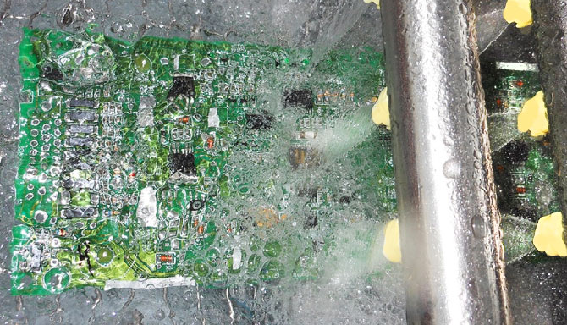
Technical Devices Company has developed patent pending Flood Box Technology for inline cleaning. The Flood Box is a contained area within the wash section of a Nu/Clean inline cleaner where the circuit board is completely submerged, allowing the fluid to flood the board without lowering or raising the conveyor. While traveling through the flood box, the circuit board is simultaneously being hit with pressurized spray from nozzles and being flooded with turbulent currents of fluid. The Flood Box is then followed by conventional top and bottom spray bars.
Chemistry Savings of up to 50%!
- Electronic assemblies are becoming smaller, more densely populated, and designed with lower standoff components. All of these make circuit boards harder to clean!
- The traditional approach to overcoming these cleaning challenges has been mainly focused on chemical solutions. Certain chemistries can help reduce the surface tension of water and allow for easier penetration into the smaller spaces in and around components.
- Of course there are drawbacks to the chemicals themselves. They are a recurring expense, and in some cases, a very large recurring expense. Depending on where you manufacture, your chemical usage may be greatly limited by local environmental regulations. Even if your particular local area environmental standards are more lax, the federal standards are becoming more and more restrictive.
- There is a better way to clean under low standoff components and
between high density circuit boards that does not involve a chemical solution,
but rather a mechanical solution.
- The conveyor does not drop or raise, but remains at a constant level.
The circuit board is placed on conveyor and travels horizontally through the flood box
in the wash section. Then it travels through the Nu/Clean in the same manner as a traditional inline cleaner.
- Because the Flood Box is a self-contained area, any chemistry loss in the wash section is great reduced. The chemistry is not being sprayed into air and being sucked up by an exhaust system as in most inline systems. The chemistry is more efficiently recycled through the Flood Box which means lower costs and easier compliance with environmental standards.
- The best news of all – chemistry may not be required! Because of the innovative way the Flood Box is able to absolutely penetrate the low clearances within the electronic assembly, chemistry to reduce the surface tension of the water may not even be necessary.
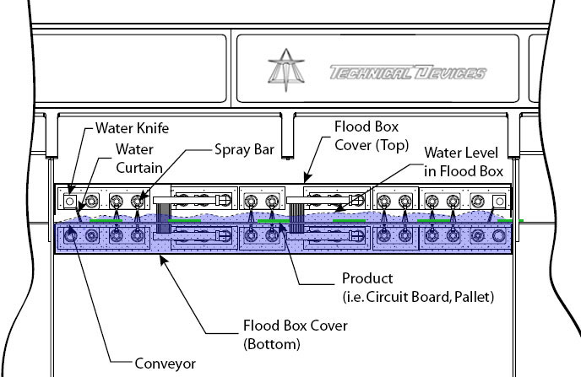
The Flood Box is a self-contained area, resulting in greatly reduced chemistry loss in the wash section. The chemistry is not being sprayed into air and being sucked up by an exhaust system as in traditional inline systems. The chemistry is more efficiently recycled through the Flood Box which means lower costs and easier compliance with environmental standards. Because of the innovative way the Flood Box is able to absolutely penetrate the low clearances within the electronic assembly, the amount of chemistry needed to clean assemblies may be significantly reduced.
The amount of money saved on just chemistry consumption makes the
Nu/Clean Flood Box Inline Cleaner
the smart choice for cleaning!

To see the Flood Box in person, schedule a demonstration for your product
at Technical Devices Company‘s Demo Facility in Los Angeles, CA. sales@technicaldev.com
For more information on the Flood Box or Aqueous Cleaning
visit our website at www.TechnicalDev.com

