Technical Devices Company has expanded it’s award winning line of
Nu/Clean Inline Flood Box Cleaners to include Industrial Cleaners

( We just delivered our 4th parts cleaner to a Major Electric Car Manufacturer!)

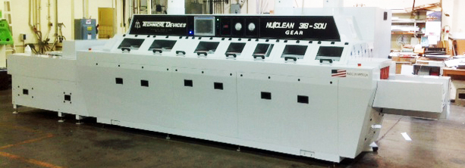
Nu/Clean Industrial Inline Cleaner
The Nu/Clean Inline Aqueous Cleaner isn’t just for circuit boards! We’ve customized our cleaners to process all sorts of things from helicopter rotor blades, to rearview mirrors, to copper bars, to high precision gears, to television screen, to batteries, to just about anything our happy customers need cleaned.  Due to the high demand for industrial parts cleaning, Technical Devices Company has developed specially designed inline cleaners for industrial cleaning processes. In fact these cleaners have proven so successful and cost-effective, there are currently 4 units in place at a leading Electric Car Manufacturer as part of their integrated assembly lines.  Our industrial cleaners come with custom conveyor systems which can even include demagnetizer units as shown in the middle picture on the right. We also handle etching processes as well as cleaning and include integrated skimmer systems when needed.  And of course, we offer our award winning patent pending Flood Box technology for parts cleaning, too. | 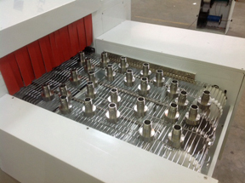  Stainless Steel Parts Exiting the Nu/Clean Industrial Cleaner  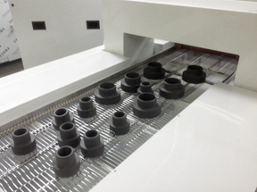  Part passing under the built in demagnetizing unit at the entrance to the Nu/Clean Industrial Cleaner  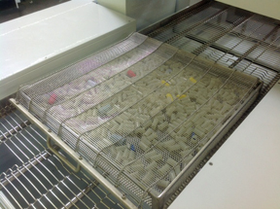  Small Plastic parts run in baskets

