FOR IMMEDIATE RELEASE

Contact:
Todd O’Neil: Business Development Mgr.
1-603-819-8933
toneil@scienscope.com

Scienscope to Launch New X-ray Component Counter at APEX

Chino, CA — January 2016 — Scienscope International, a complete inspection solutions provider, will exhibit in Booth #1038 at the 2016 IPC APEX EXPO, scheduled to take place March 15-17, 2016 at the Las Vegas Convention Center. Scienscope will launch their new AXI5100c X-ray Component Counter for the first time and showcase some of its flagship AXI products: X-SCOPE 1800, X-SCOPE 6000 and AXI-8000.
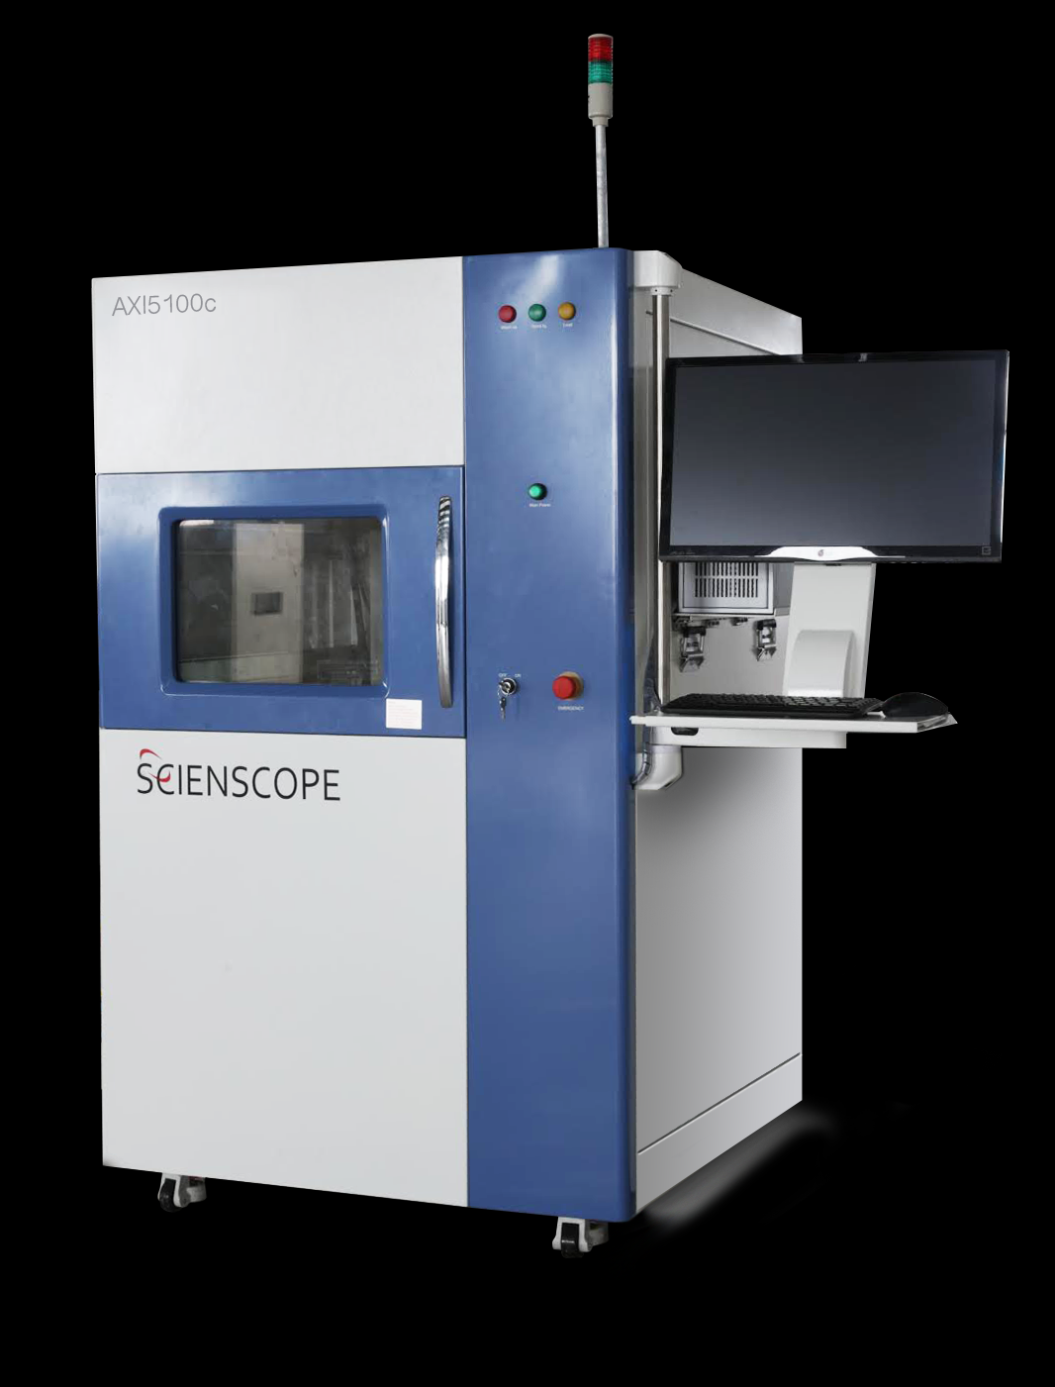
The AXI5100c is a new innovation in counting components, capable of counting the latest 03015s as well as (4) 7" or (1) 15" reels of various thicknesses. Beyond counting reels, the AXI5100c can also count components in ESD bags, storage sticks, and trays.

Even more interesting, the AXI5100c also can perform traditional X-ray inspection of electronics and counterfeit component detection, making it the obvious choice for flexibility. The AXI5100c -i is a fully automated inline system that can handle loading and unloading of components using various conveyors, loaders/unloaders and even robots.

The X-SCOPE 1800 Cabinet X-ray Inspection System is a full-featured entry level system, featuring a state-of-the-art 90 kV micro-focus X-ray tube and a standard 4″ x 3″ digital flat panel detector with tilting capability.

The X-SCOPE 6000 is a more advanced system, including a 130Kv micro-focus X-ray tube with optional 5" x 5" digital flat panel detector or optional ultra-resolution digital flat panel detector. Both have tilting capability up to 65°. The X-SCOPE 6000 also has a rotating table that can move a total of 350° (+/- 175°).

The AXI-8000 is a fully automated inline X-ray machine that can either inspect with traditional 2D or an advanced Planar CT for reconstruction of 3D images. There is no movement of the sample once it is in place. After reconstruction, each slice can be viewed, giving greater detail of each layer in comparison to traditional 2D with overlaying images.

For more information, please email Scienscope at info@scienscope.com, call 1-800-216-1800 or visit www.scienscope.com.

###

About Scienscope International
Scienscope was founded in 1994 to meet the growing need for reliable and affordable general-purpose optical and video inspection solutions for the electronics and PCB industries. The company began with basic stereo zoom microscopes used for SMT inspection and rework of circuit boards and electromechanical assemblies with a commitment to quality, value and support. Over the past 20 years, Scienscope has evolved to become a complete inspection solution provider, offering both offline and inline X-Ray systems, Video coordinate measurement systems, Video inspection systems, and microscopes to meet a wide variety of applications and manufacturing quality requirements.

