Super Dry Nitrogen-free Low Temperature Baking and Storage
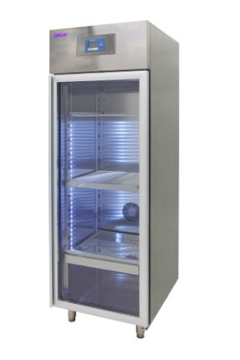
Moisture specialist Super Dry (www.superdry.info) will feature its broad range of desiccant cabinets at this year’s APEX in Las Vegas. Visitors to Booth 425 will learn the processing and financial benefits of replacing costly nitrogen and eliminating high temperature baking for the protection of moisture sensitive components and PCBs.

The continuing miniaturization of electronics, including thinner components and new materials has made the management of moisture sensitivity an increasingly critical element of product reliability. Lead free processing is further challenging manufacturers to manage larger and larger volumes of parts in a controlled and traceable manner.
IPC /JEDEC-J-Std-033C specifies a maximum of 5% RH to safely store MSDs. This simply stops the clock... it does not remove moisture nor restore MSD floor life. Lead free processes, which create up to 3x the saturated vapor pressure within components, extend the risks of cracking, popcorning and delamination that cause field failures. Ultra-low humidity desiccant cabinets not only safely store components, they can also remove moisture and reset component floor life, while providing oxidation prevention equivalent to nitrogen at a fraction of the cost.

Learn more at www.totech.eu..com
Ends
About Super Dry^{R}
Delivering globally to the world’s top tier OEM and EMS companies, and manufacturing in Asia and in Europe, Totech Super Dry has become the industry measure for ultra low humidity storage cabinets. Proper control of moisture sensitive devices (MSDs) per IPC and JEDEC standards has become more critical than ever since the introduction of lead free and its higher reflow temperatures. Boasting <1% relative humidity control and the fastest recovery times, Super Dry cabinets are available in a wide range of sizes and configurations, all with certified performance control measures.

Company Contact | Agency Contact
Richard Heimsch  Super Dry  235 Colovista Parkway  Austin, TX 78602  USA | Helena Osborn  Unit 1, Cutbush Court  Danehill  Lower Earley  Reading, RG6 4UW  UK
Tel: +1 312 513 3513  Email: info@totechamericas.com  www.superdry.info | Tel: +44 1189 759880  Email: helena.osborn@protean.co.uk  www.proteanmarketing.com

