Press Release
IPC/APEX Las Vegas, March 2016 Booth#1910
Fabcon is proud to introduce the OLEC SSI Accubeam.

Fabcon is proud to introduce the OLEC Accubeam SSi-Solid State Imaging Systems. The SSI uses a solid state light source with high depth of focus and guaranteed high performance. The delivered power at the exposure surface will provide quick and effective exposure power for most conventional dry film and solder masks.

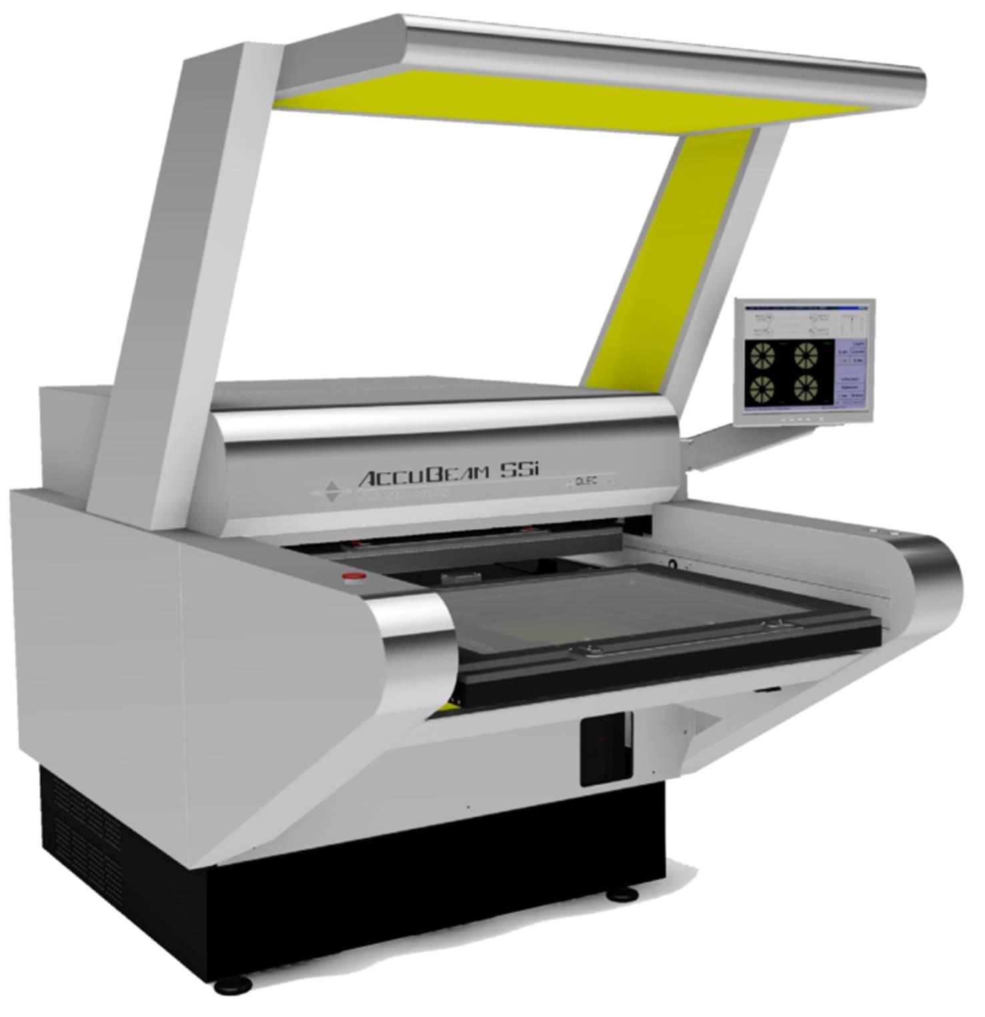
The technology answers industry demands for high resolution imaging at a reasonable price with very low energy costs. OLEC's renowned registration system and imaging platforms have been enhanced by adding SSi-Solid State Imaging. The product can be configured to image; Flat Panel Displays, High Density Interconnect, Photo Chemical Machining, PCB inner layer, outer layers and solder mask.

Bert Ohlig, chairman of Fabcon explains “The new platform is extremely flexible allowing us to use single sources for small and multiple sources for larger formats and long formats. The high degree of collimation is perfect for the extreme resolution, tight tolerance and g high through-put. .” Greg Self, V.P. Electronics of Fabcon comments, “the Accubem SSI provides imaging flexibility for all applications, long, large format PCB and chemical milling demands “.

For over 35 years Fabcon has provided products for the graphic arts, packaging, printed circuit, screenprint, and digital imaging markets under the OLEC brand. With distribution in over fifty countries, Fabcon is housed on a 13 acre site near Orange County Airport in Santa Ana, California.

