Press Release
IPC/APEX Las Vegas, March 2016
Fabcon is proud to introduce the OLEC Microprint Di imaging Systems.

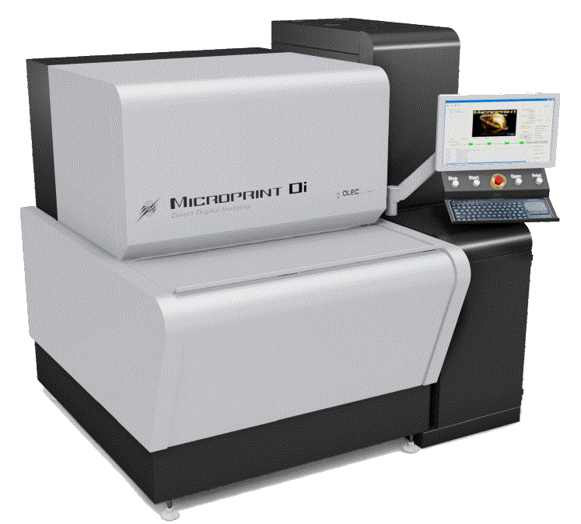
The Microprint Di uses a Laser based light source with high depth of focus and guaranteed high performance. The delivered power at the exposure surface will provide quick and effective exposure power for most all LDI, conventional dry film. Programmable resolution and speed control provides manufacturing flexibility to fit most requirements. Our unique imaging technology insures sharp exposed traces and new scrolling method minimizes edge smearing issues

The technology answers industry demands for direct imaging of circuit boards. OLEC's renowned registration system and imaging platforms have been enhanced by adding the combination of collimated laser lighting with DLP direct imaging technology. The product can be configured to image; Flat Panel Displays, High Density Interconnect, Photo Chemical Machining, PCB inner layer, outer layers and solder mask.

Bert Ohlig, chairman of Fabcon explains “The payback for the new platform is extremely short with the increased yields from tight tolerance registration by eliminating the use of artwork photo-tools, short setup time, and the high resolution capability. The MicroPrint DI makes available the right tool for todays and tomorrow’s imaging production demands.” Greg Self, V.P. Electronics of Fabcon comments, “The industry demands change almost daily. With the introduction of the AccuBeam, we continue to provide the industry with state of the art solutions”.

For over 35 years Fabcon has provided products for the graphic arts, packaging, printed circuit, screenprint, and digital imaging markets under the OLEC brand. With distribution in over fifty countries, Fabcon is housed on a 13 acre site near Orange County Airport in Santa Ana, California.

