Contact:
Kristal L. Yelton
Marketing Manager
T 513-772-8810 x3245
E yelton@cszinc.com

FOR IMMEDIATE RELEASE

Compact Vibration Table for Testing Small Components
Dual-purpose vibration system may be used with Environmental chamber for
Combined temperature/vibration testing

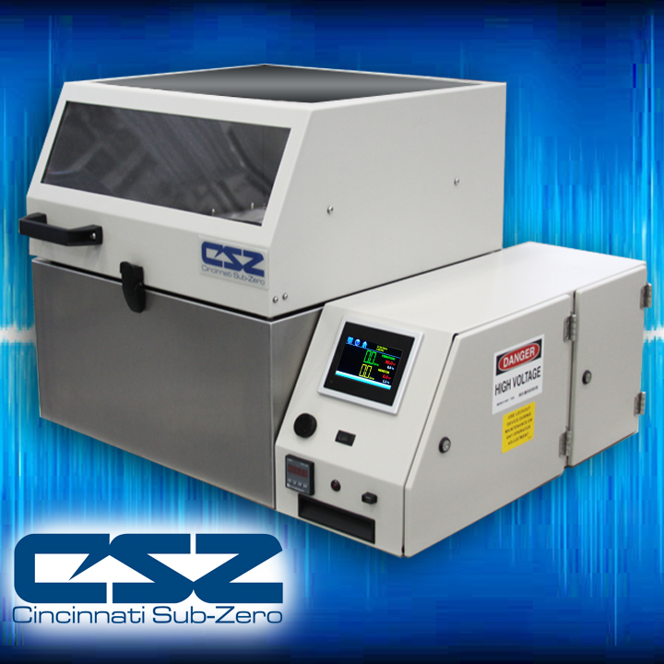
Cincinnati Sub-Zero’s (CSZ) new TCB-1.3 benchtop vibration table is ideal for reliability testing of compact products and electronics. The dual-purpose system is available in a 16” x 16” (40cm x 40cm) table size and may be used as a stand-alone vibration table for vibration testing or placed inside of an environmental chamber for combined vibration & temperature testing offering customers’ flexibility and greater return on their investment.

Equipped with an all-axis vibration system, the TCB-1.3 utilizes four pneumatically-actuated vibration hammers providing 6 dof random vibration with x,y,z axis and roll, pitch and yaw rotation. The chamber comes standard with two accelerometers, one for control and one vibration monitor with a vibration range of 1 to 60 GRMs.

Design includes a removable lid & easy-lift off control console to allow the table base to be placed inside a typical 16 cu. ft. (456L) or larger chamber and can be operated in a temperature range of -70°C to +168°C. Utilizing random vibration technology combined with an environmental chamber, provides an cost-effective method to perform combined temperature/vibration testing.

Bob Nelson, Vice President & GM, said, “This table allows our customers to economically expand their testing capabilities and provides them with another tool to help discover product failures and make more robust products.”

The chamber is equipped with 115V electrical plug allowing for easy installation. Standard features include vibration safety limit, audible alarm, 2” access port, and more. Vibration table incorporates CSZ’s EZT-570S Touch Screen Controller, equipped with state-of-the-art features such as automated alarm text/email, remote monitoring and control, data logging, trend plots and more. CSZ’s VibTrak™ software offers full control of the CSZ environmental chamber and benchtop table. Software also includes the ability to generate PSD curves.

CSZ will be featuring the Benchtop Vibration table at the APEX2016 show in San Diego. Visit us at booth #1359 to learn more.

About Cincinnati Sub-Zero (CSZ)
CSZ provides standard & custom-designed environmental test chambers including stability chambers, temperature-cycling chambers, humidity chambers, accelerated stress-testing chambers, HALT & HASS chambers, thermal-shock chambers, altitude chambers, AGREE vibration chambers, industrial freezers, and more. Sizes range from small benchtop chambers to full walk-in / drive –in rooms. Please visit http://www.cszindustrial.com for additional information.

