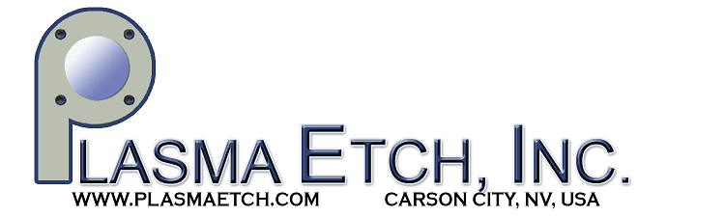
For Immediate Release: May 22, 2015

Plasma Etch, Inc. announces attractive pricing breakthrough: commercial grade plasma cleaning system for only $5,900.

Carson City, NV – Plasma Etch Inc, a leader in plasma innovation, announces attractive pricing on their entry level plasma cleaner for small research facilities and universities.

The PE-25 low cost plasma cleaner is an affordable, entry level option for plasma treatment. The company hails it as a robust machine which is perfect for small production facilities, research labs, universities, medical facilities, or any industry needing a small-scale, cost-effective plasma treatment solution.

This unit is a great solution for plasma cleaning and surface modification, including plasma desmear.

This opening price point system also includes industry leading features such as dry vacuum pump with a vacuum pump surge system. The unit is controlled by any PC or laptop and includes a light tower for easy to read indication of the steps of the plasma processing sequence.

Check out the PE-25 and all of Plasma Etch’s products for sale or rent on their website: www.plasmaetch.com

About Plasma Etch: Plasma Etch is a leading manufacturer and industry innovator since 1980. The company has held several patents for the invention, development and manufacturing of groundbreaking innovations; paving the way for plasma technology and the enhancement of quality manufacturing worldwide. Plasma Etch specializes in plasma cleaning solutions of all sizes. Their products are industry proven, and set the standard for reliability, speed and uniformity in plasma processing.

Contact information:
Plasma Etch, Inc.
3522 Arrowhead Drive
Carson City, NV 89706
(775) 883-1366
www.plasmaetch.com

###

